

# SYNOPSIS

CSE-326

FINAL REPORT

**Real Estate Website**

GROUP MEMBER:

Muneer Basha RK19SJB58 11917807

Vishnu Vardhan RK19SJB59 11902387

ARKAPRIYA DE RK19SJB60 11902078

**Submitted to: Sukhvir Kaur**

## 

Introduction...

# **Online real estate website:**

Internet real estate is the concept of publishing housing estates for sale or rent, and for consumers seeking to buy or rent a property. Internet real estate surfaced around 1999 when technology advanced and statistics prove that more than 1 million homes were sold by the owners themselves in just America in 2000. Some of the prime internet real estate platforms include [**Zillow**](https://en.m.wikipedia.org/wiki/Zillow)**,**[**Trulia**](https://en.m.wikipedia.org/wiki/Trulia)**,**[**Yahoo! Real Estate**](https://en.m.wikipedia.org/wiki/Yahoo!_Real_Estate)**,**[**Redfin**](https://en.m.wikipedia.org/wiki/Redfin) and [**Realtor.com**](https://en.m.wikipedia.org/wiki/Realtor.com).

This website is an online real estate business website through which a user can access its information and manage all the adding, updating, deleting the assets and some of its tasks.The Admin user can also upload any type of information regarding property selling and buying.The system is very useful for the promoters who develop apartments, hotels, villa, residential properties and commercial properties. Companies or individual agents can also advertise their property.

* A new user can also enrol in the website for new updates & will get a notification in future when new updates are available in our website.
* There is a report page in our website through which user can make a report of statistics and can also print the report for free.
* User can also upload a property by filling a google form for free.
* We have used basically, HTML5 and CSS3 for designing, styling and giving a proper content to our website and have used basic JavaScript to make a functionality on Login page & Upload page & also to report page for function like graph, statistics counter.

Flow Chart of website AAAADFGBN\ GVFGKLNNCX, aAAAA

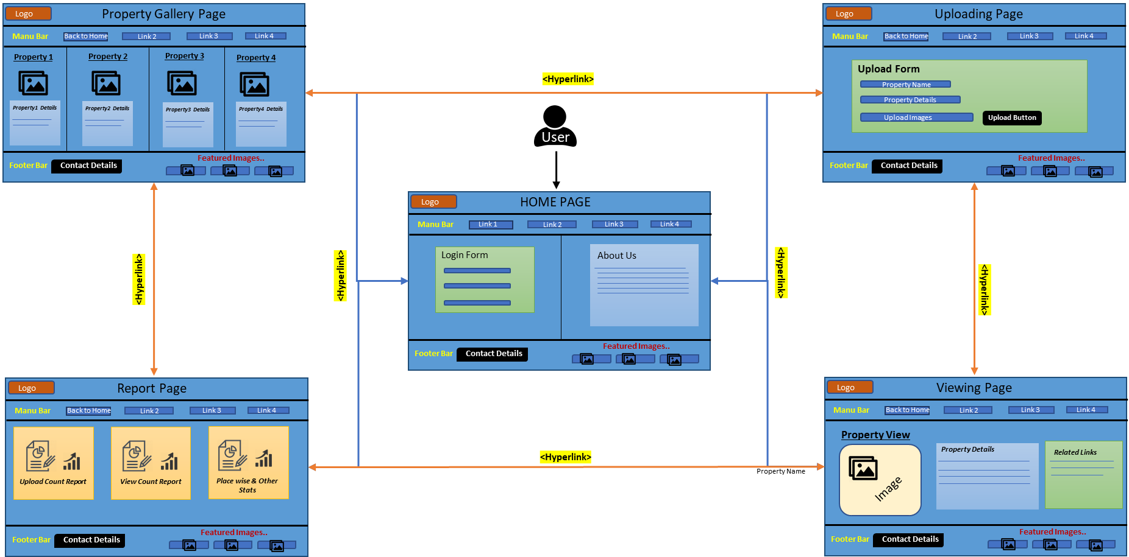

* **We have divided our “REAL ESTATE” website into following modules/sections:**
* Header section
* Body section
* Sidebar
* Downbar
* Footer section

Different Modules of Website.

Header Section:

* In the header section we used a backgroud image.
* It contains **a logo** on the left side of the header section.
* There is a Navigation Bar in the header section.
* Navigation Bar contains Home page,Uploading page,Gallery page,Viewing page,Reporting page.We use **dropdown css** under the <li> tag of view page.
* When the client clicks on any of the following navigation bar the page will be directed to that specific module of specific ID.
* User can log in to any page from this section.
* In this section we use a <marquee> tag.
* In this section we use HTML and CSS.

Image of Header Section:



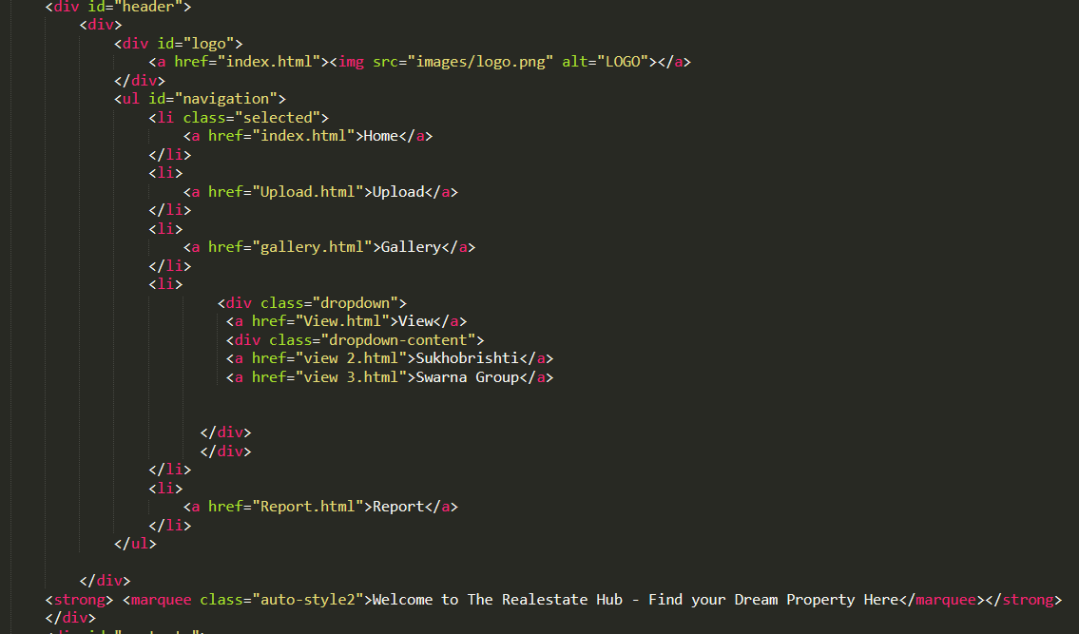Code of Header Section:

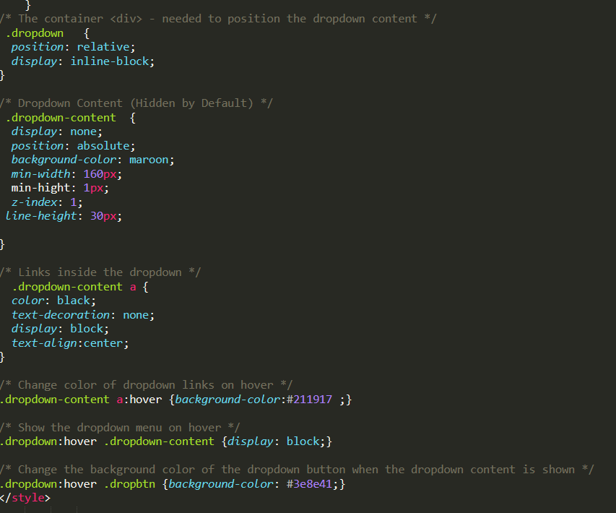

Body Section:

* Body section of home page:

1. In this page we use a background Video.
2. In this page we made a log in form in & this will redirect the Gallery page. **Further the sign up button is linked with google form for New user registration.**
3. In this page we create a devision & under that devision we keep our About Us section & create three sub division.
4. **The hoverclass css** is used there to have such awesome effect with little transition.
5. In the log in form we use HTML for creating form,CSS for designing the form and buttons & **Java Script for form validation**.

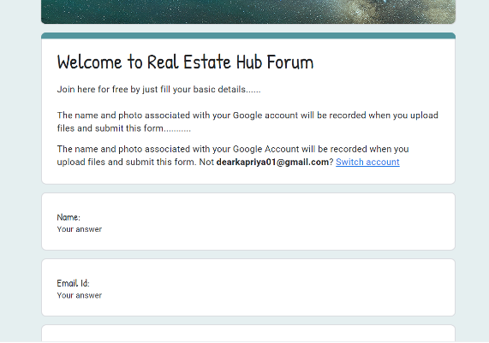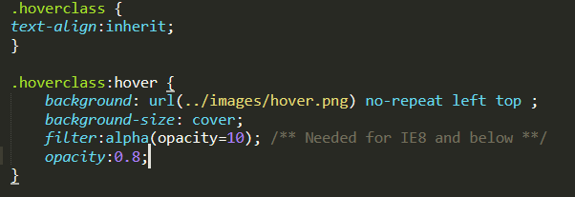

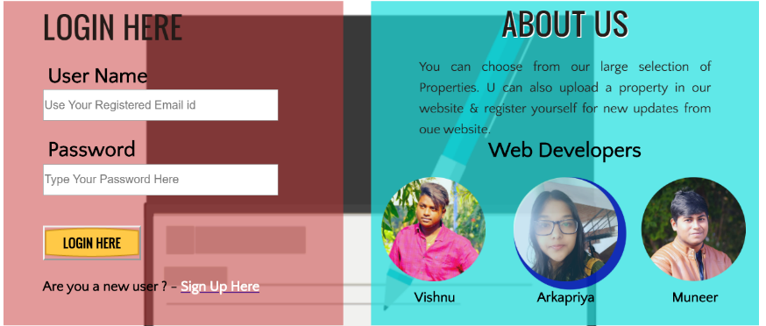

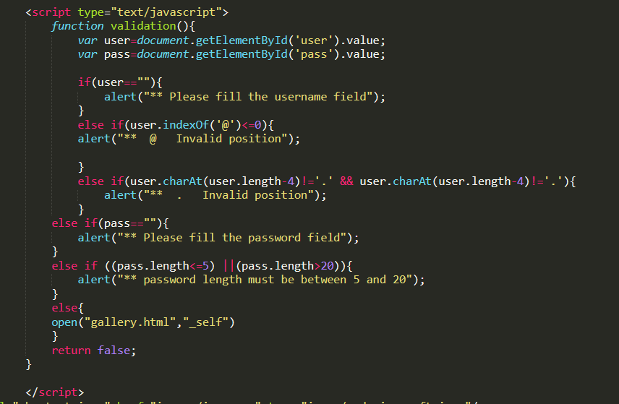

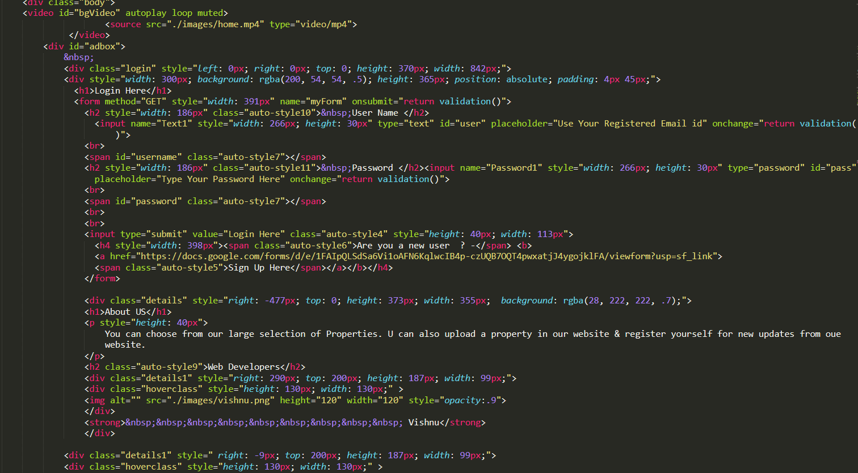

Code Of Body Section of Home Page

* Body section of uploading page:

1. In this page we create **uploading form** **& upload button .**
2. Here user can upload any type of property details and property image.**Further the Upload button is linked with google form for uploading any type of property.**
3. In the uploading form we use HTML for creating form,CSS for designing the form and buttons & **Java Script for form validation**.

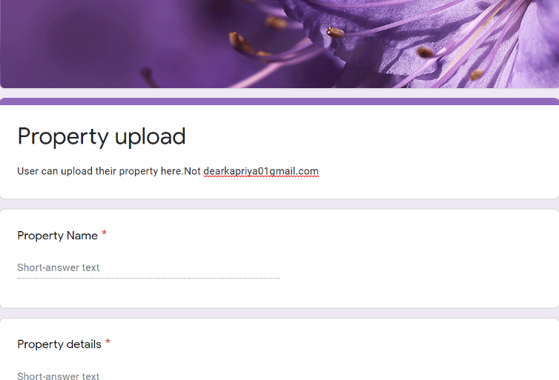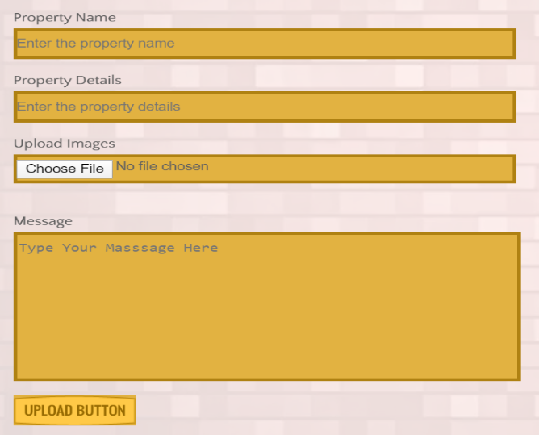

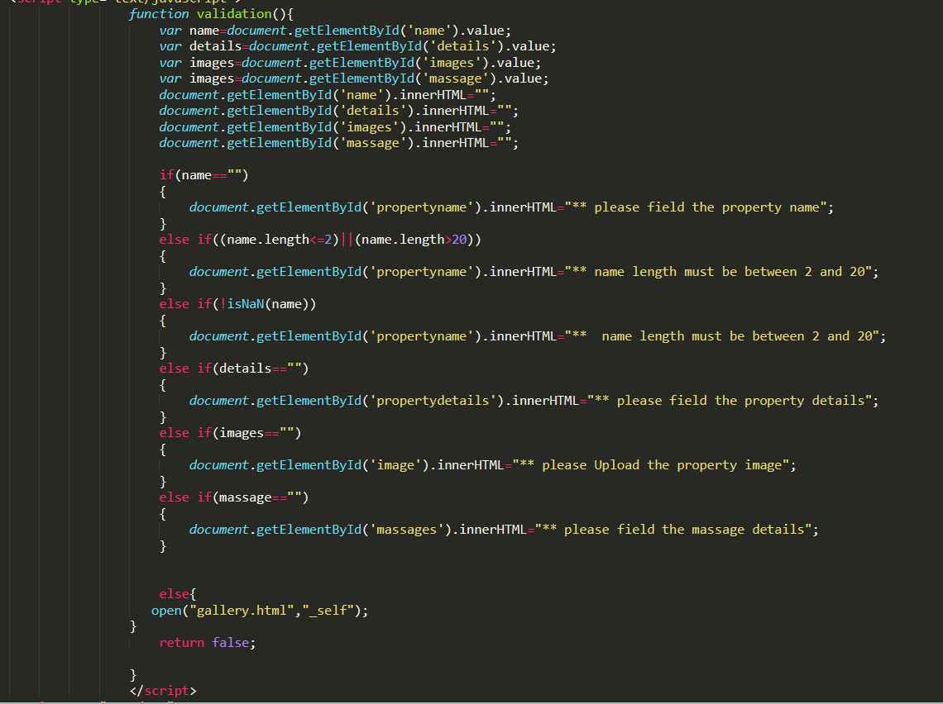

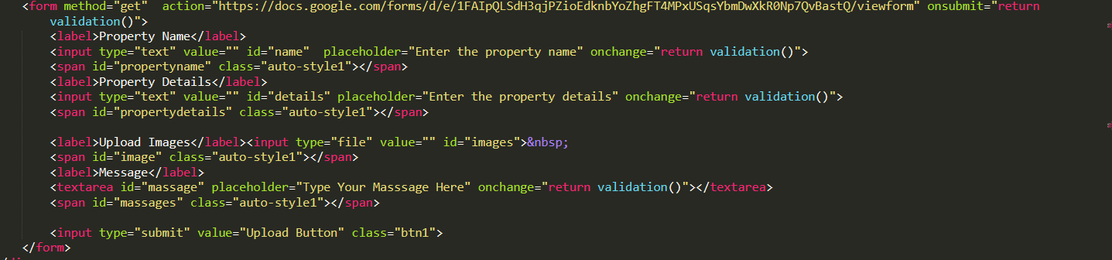

Code Of Body Section of Upload Page

* Body section of gallery page:

1. In this page there is many type of property details & images of property.
2. Each of the property detail is hyper linked to view page.
3. **we use <iframe> tag to upload a youtube video in this section.**
4. We use three div in the body section of these page.

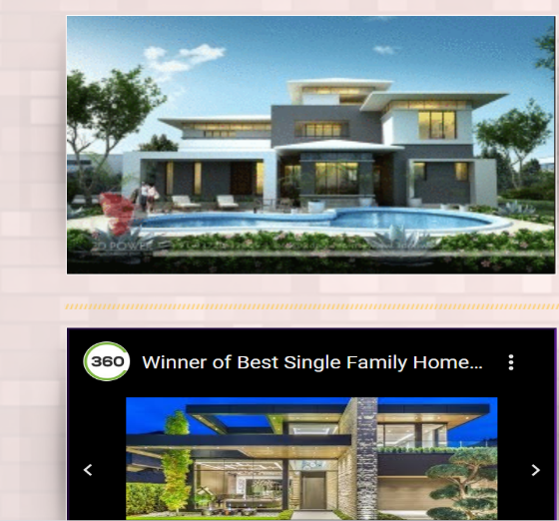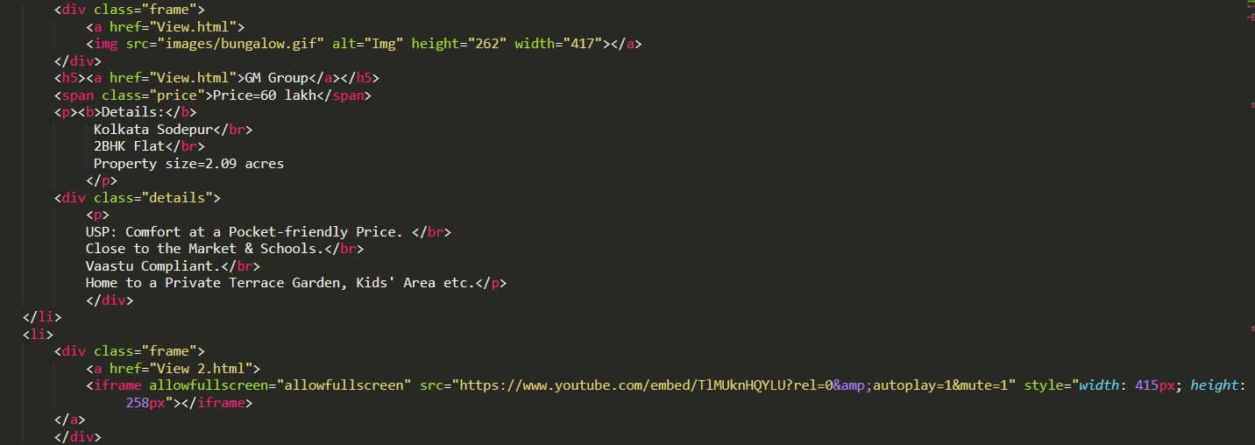

c

* Body section of View page:

1. Each of the image of gallery page is hyper linked to 3 diff view page.
2. User can log in to view page for further details.

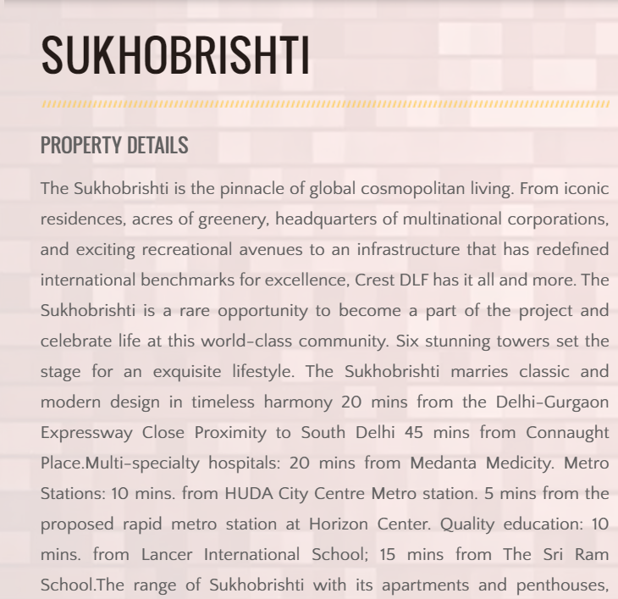

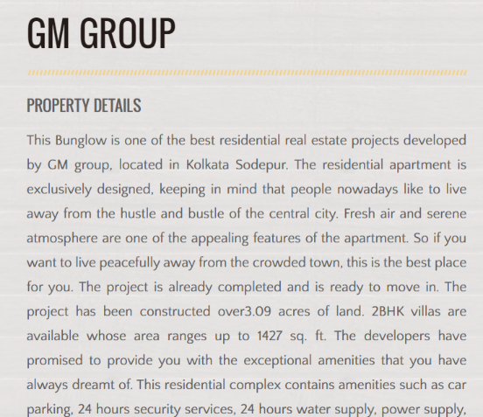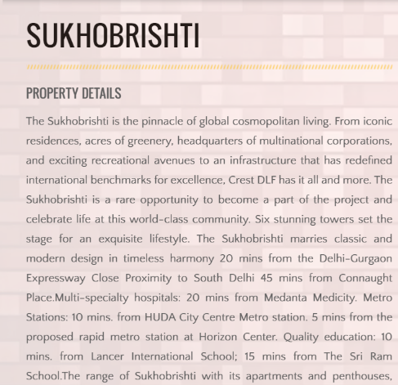

* Body section of Report page:

1. In this section create **a counter** using **numscoller** **javascript** library.
2. In this section of report page we discuss the statistics of our webpage.
3. We create a **line type & pie type graph using javascript library Chart.js.**
4. We use **toggle switch** using css.
5. We create three buttons using css and HTML-**printButton,MonthwiseButton,YearwiseButton**
6. User can print the graph by clicking the print button & can see the pie type & line type graph by clicking monthwise & yearwise button.

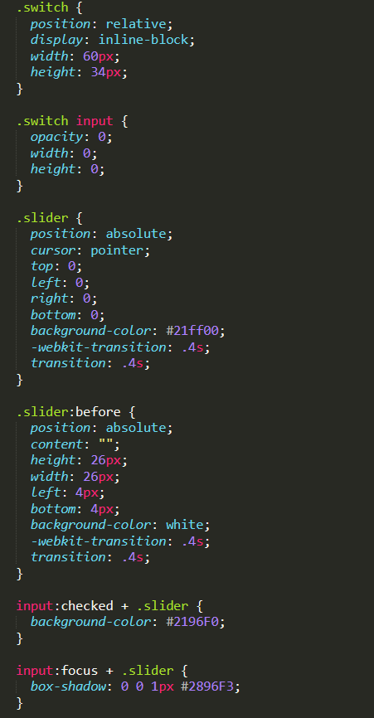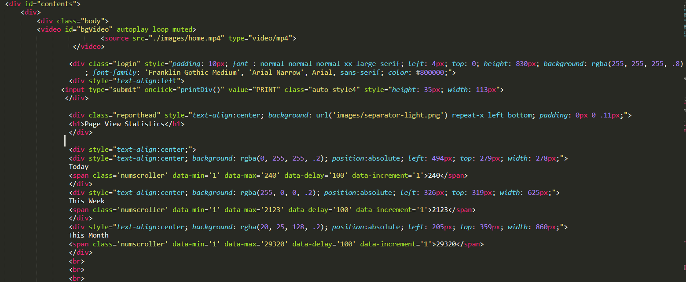

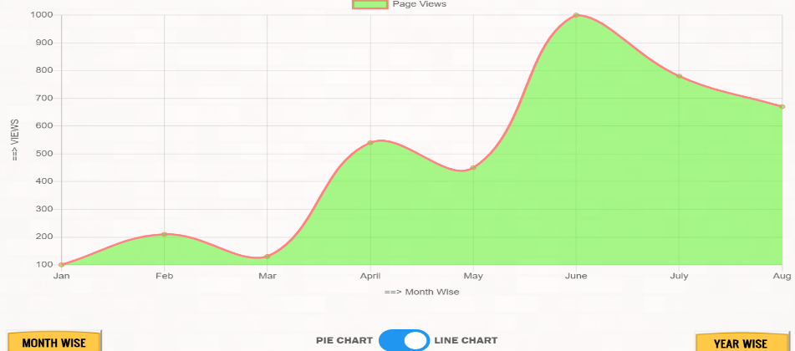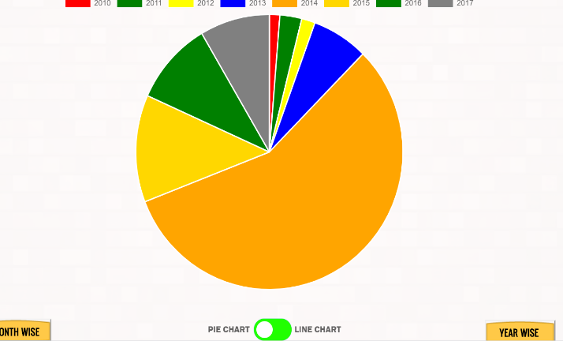

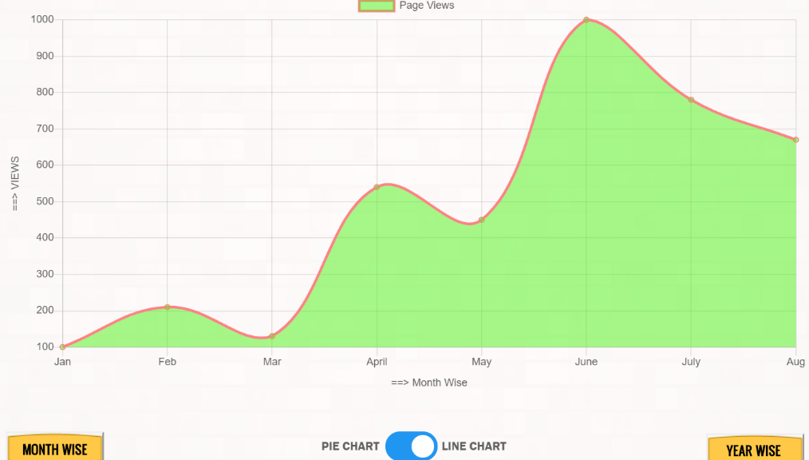

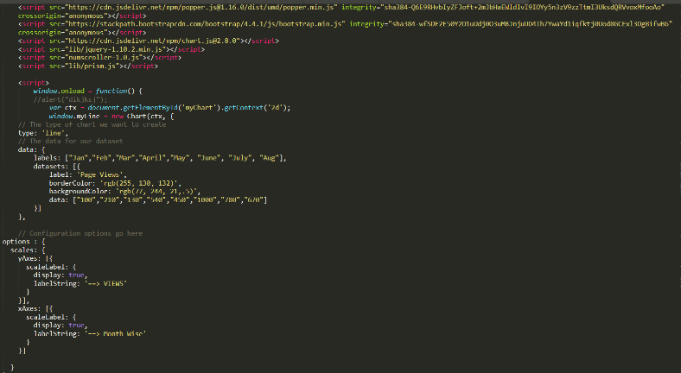

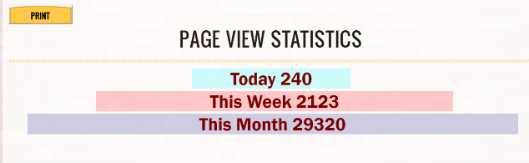

* Sidebar Section:

1. We keep this section under a division in Upload page,View page & Gallery page.
2. User can many images & special features of properties in this section.

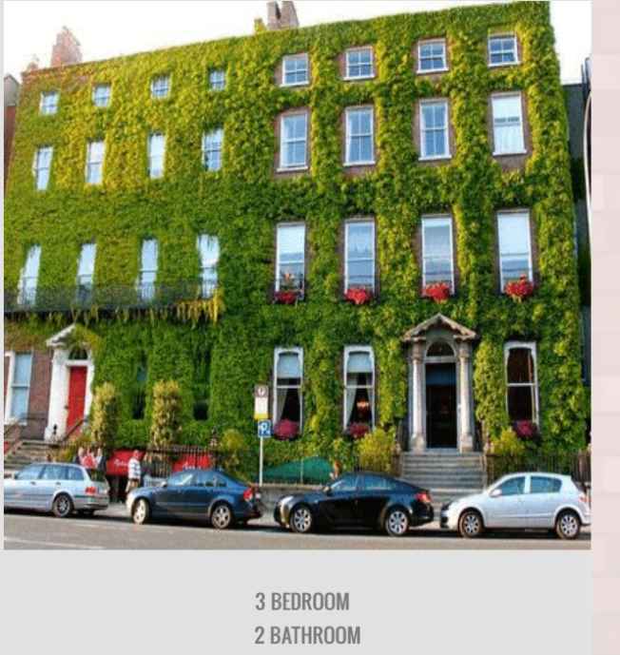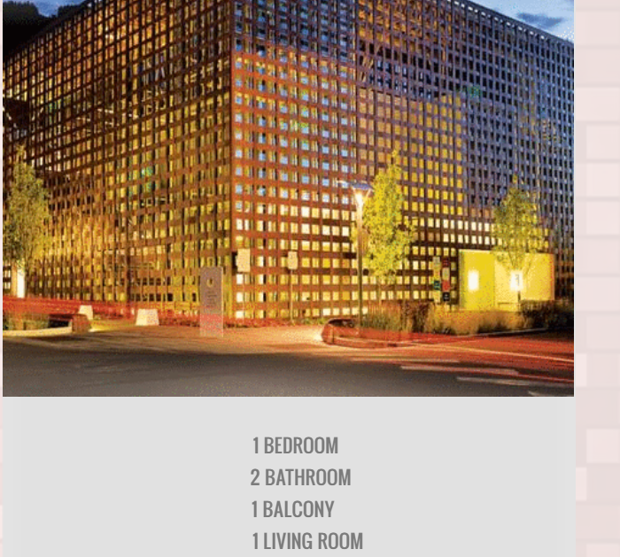

* Downbar Section:

1. We create **three division** in this section.
2. We use a <marquee> tag.

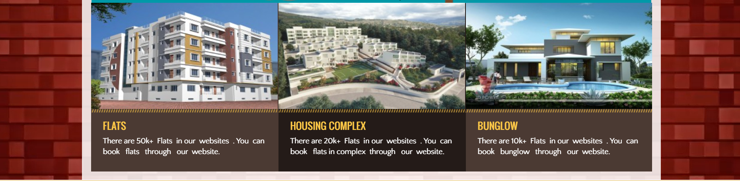

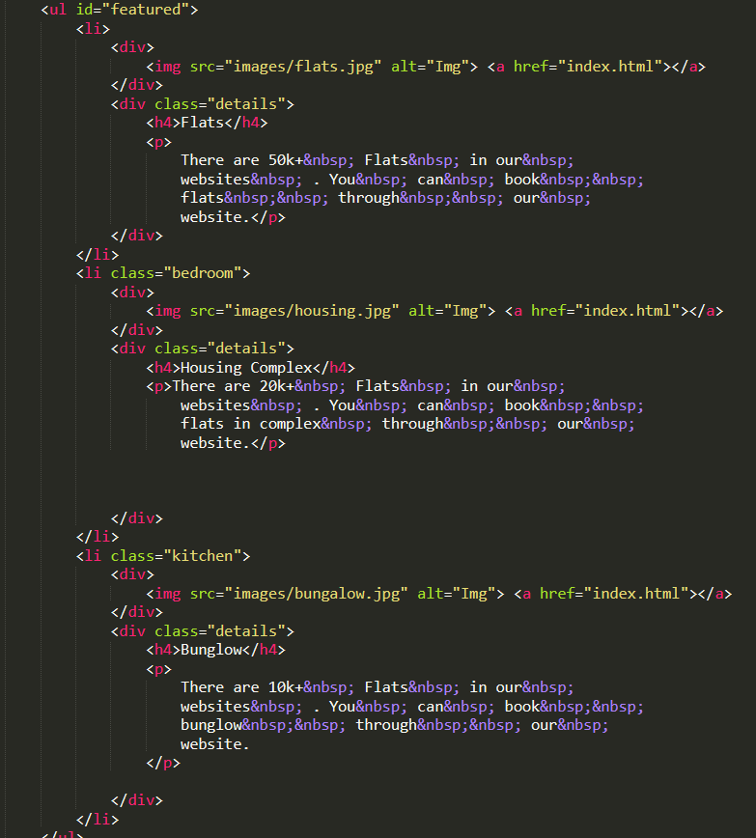

Footer Section:

* In the footer section we used a background image.
* Four divisions are made for Four sections contain recent updates of our website,contact us, sign up and social media links.
* In this section user can register himself for new updates from our website. **Further the sign up button is linked with google form for further registration & we use <iframe> tag in the contact section.**
* Recent updates division contains the recent properties details and quiz contests details.
* Contact us division contains the contact details of developers.
* Social media division links the social media account of our main developer for further contact.

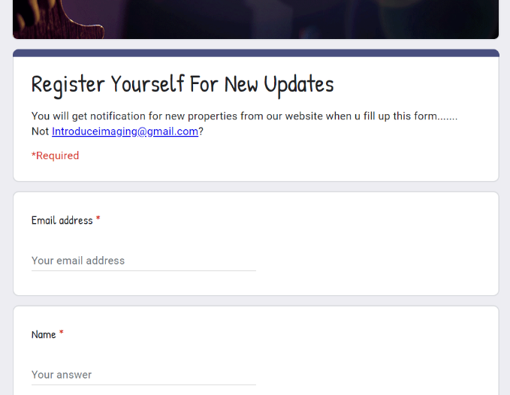

Code of Footer Section:

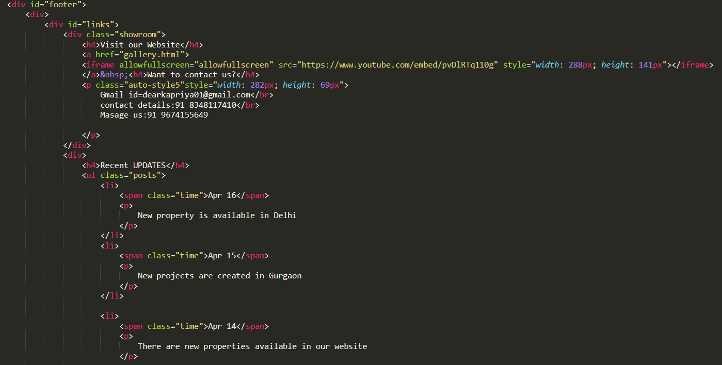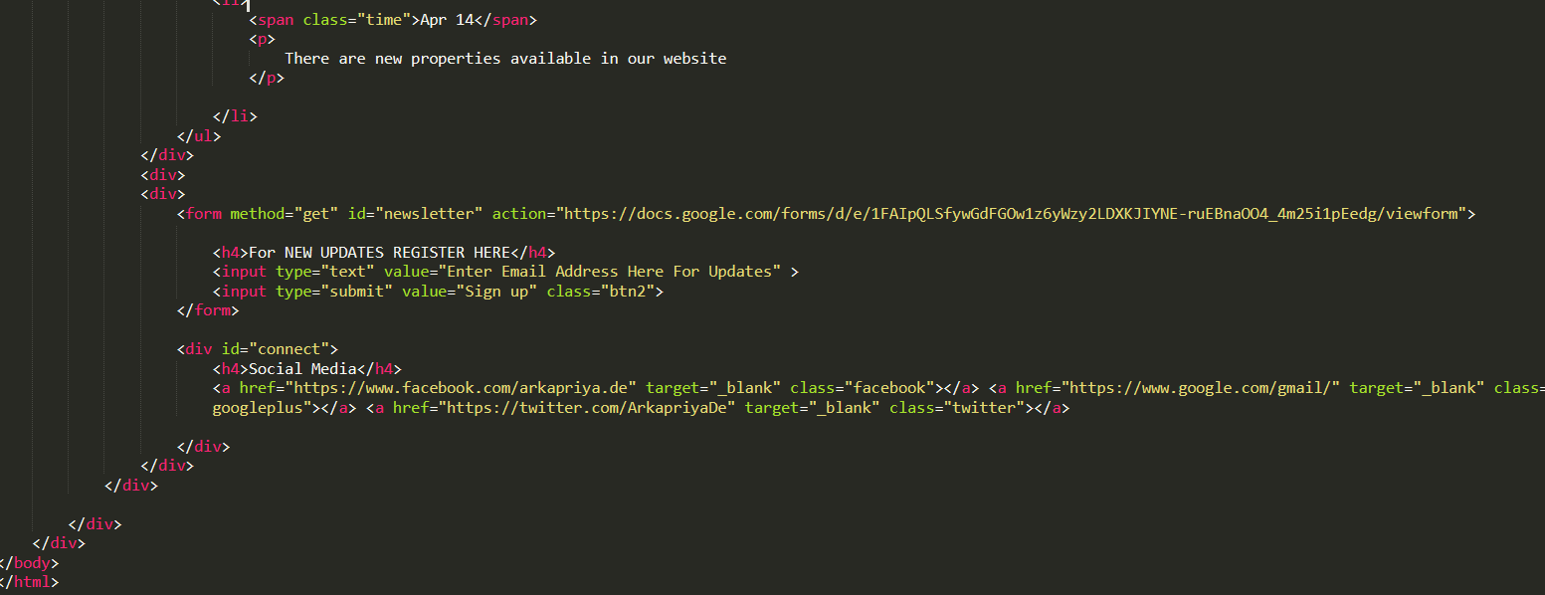

Distribution of Modules Between Team Members:`

1. Arkapriya De:

* Header
* Navigation bar
* Body section of Home Page
* Log In form
* Uploading Form
* Body section of Report Page
* Count report and graphs
* Body section of View Page
* Footer

2.Muneer Basha:

* Body section of Upload Page
* Body section of Property 1 Page
* Sidebar section

3.Vihnu Vrdhan:

* Body section of Gallery Page
* Body section of Property 2 Page
* Downbar section

SCREENSHOT OF WEBSITE:

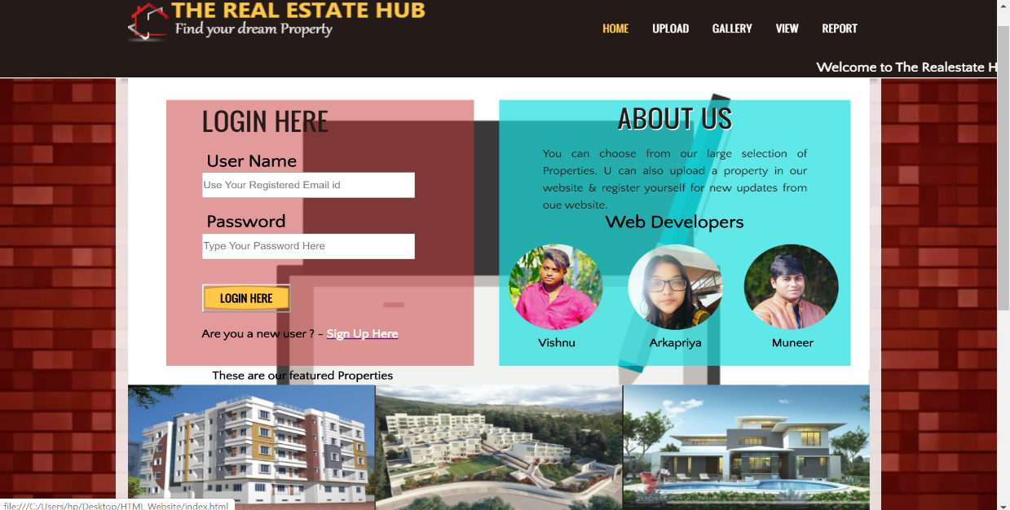

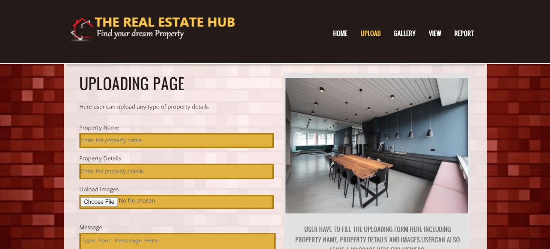

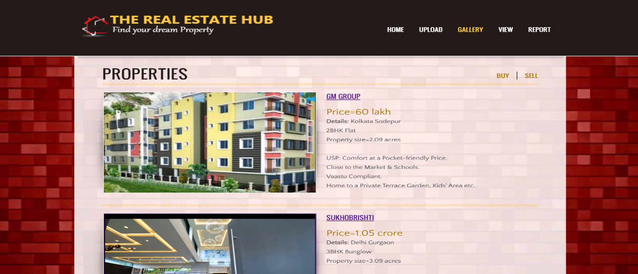

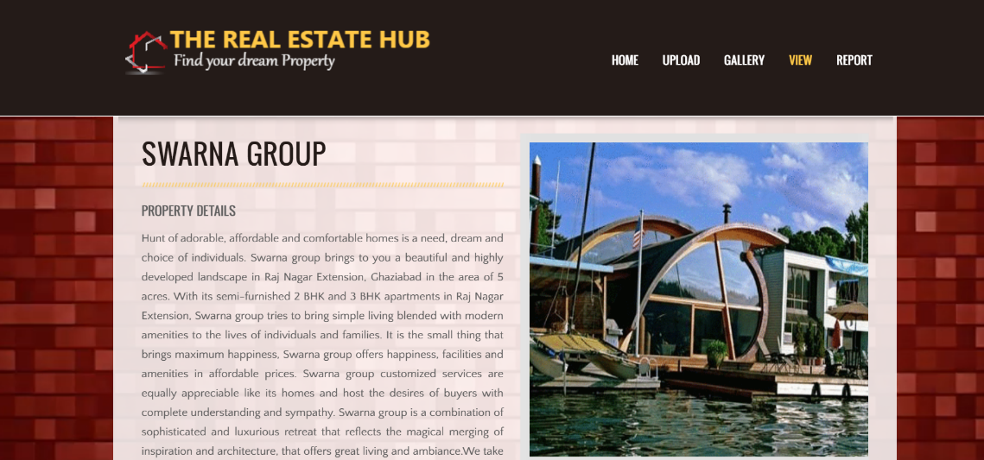

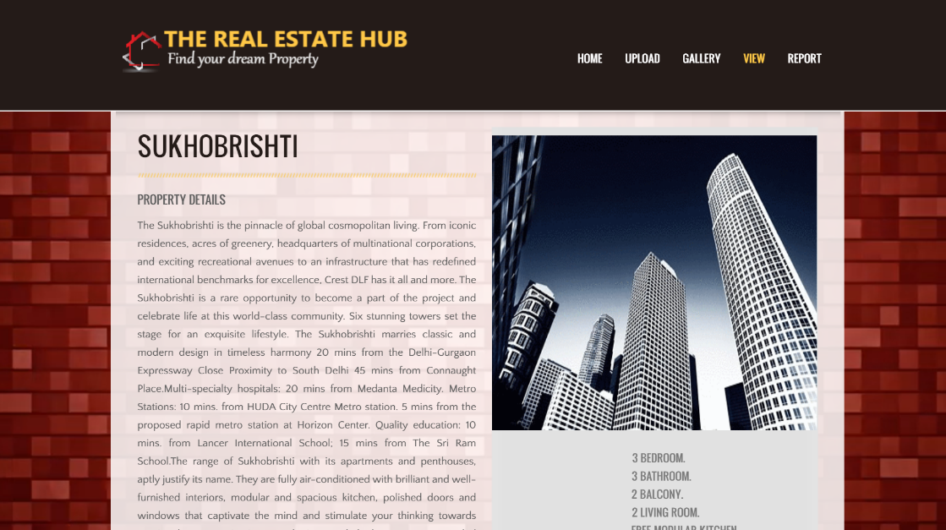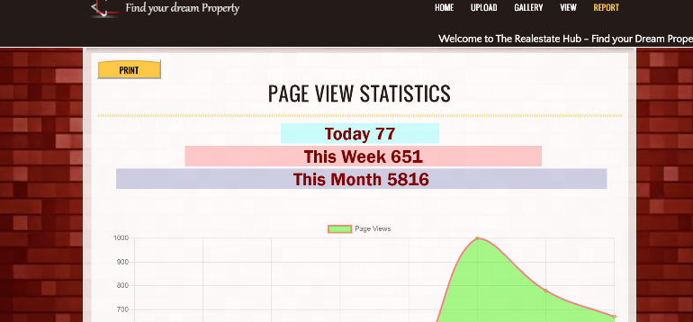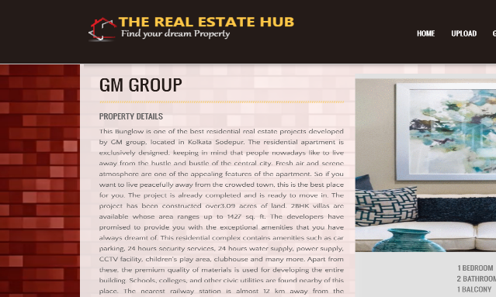

Link for youtube video:

<https://www.youtube.com/watch?v=MnSjsvTiIhc&t=>